**NBC 10 RUNDOWNS**

**11/15/2024**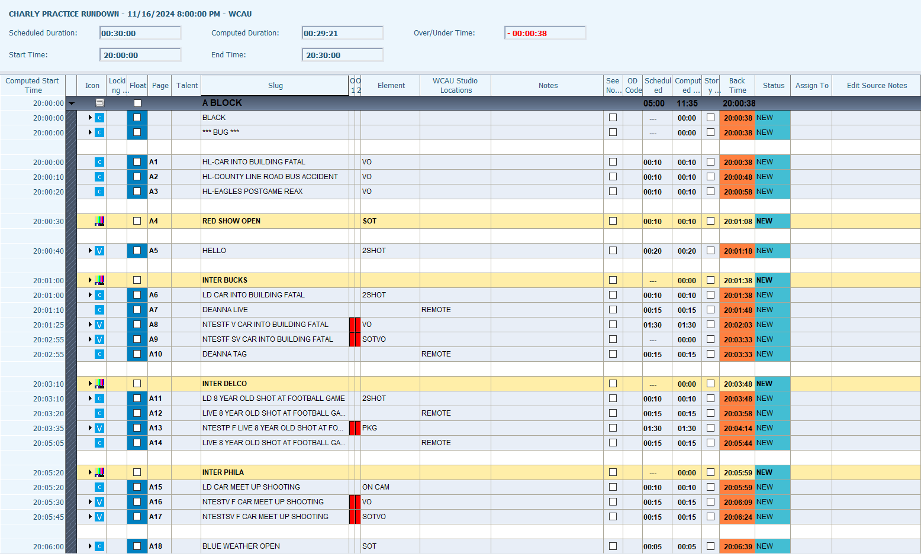

**11/8/2024**

**10/25/2024**

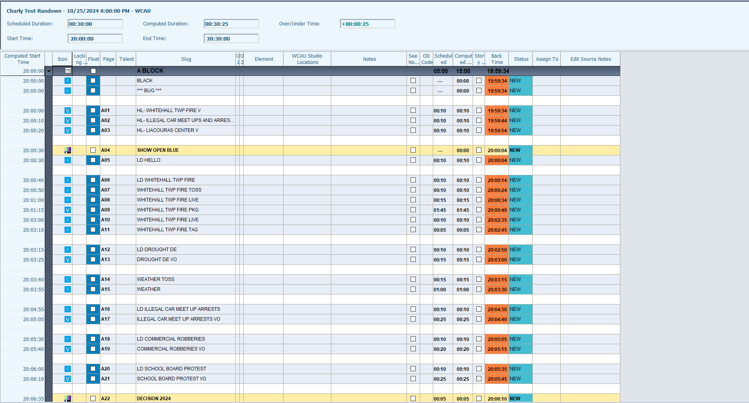

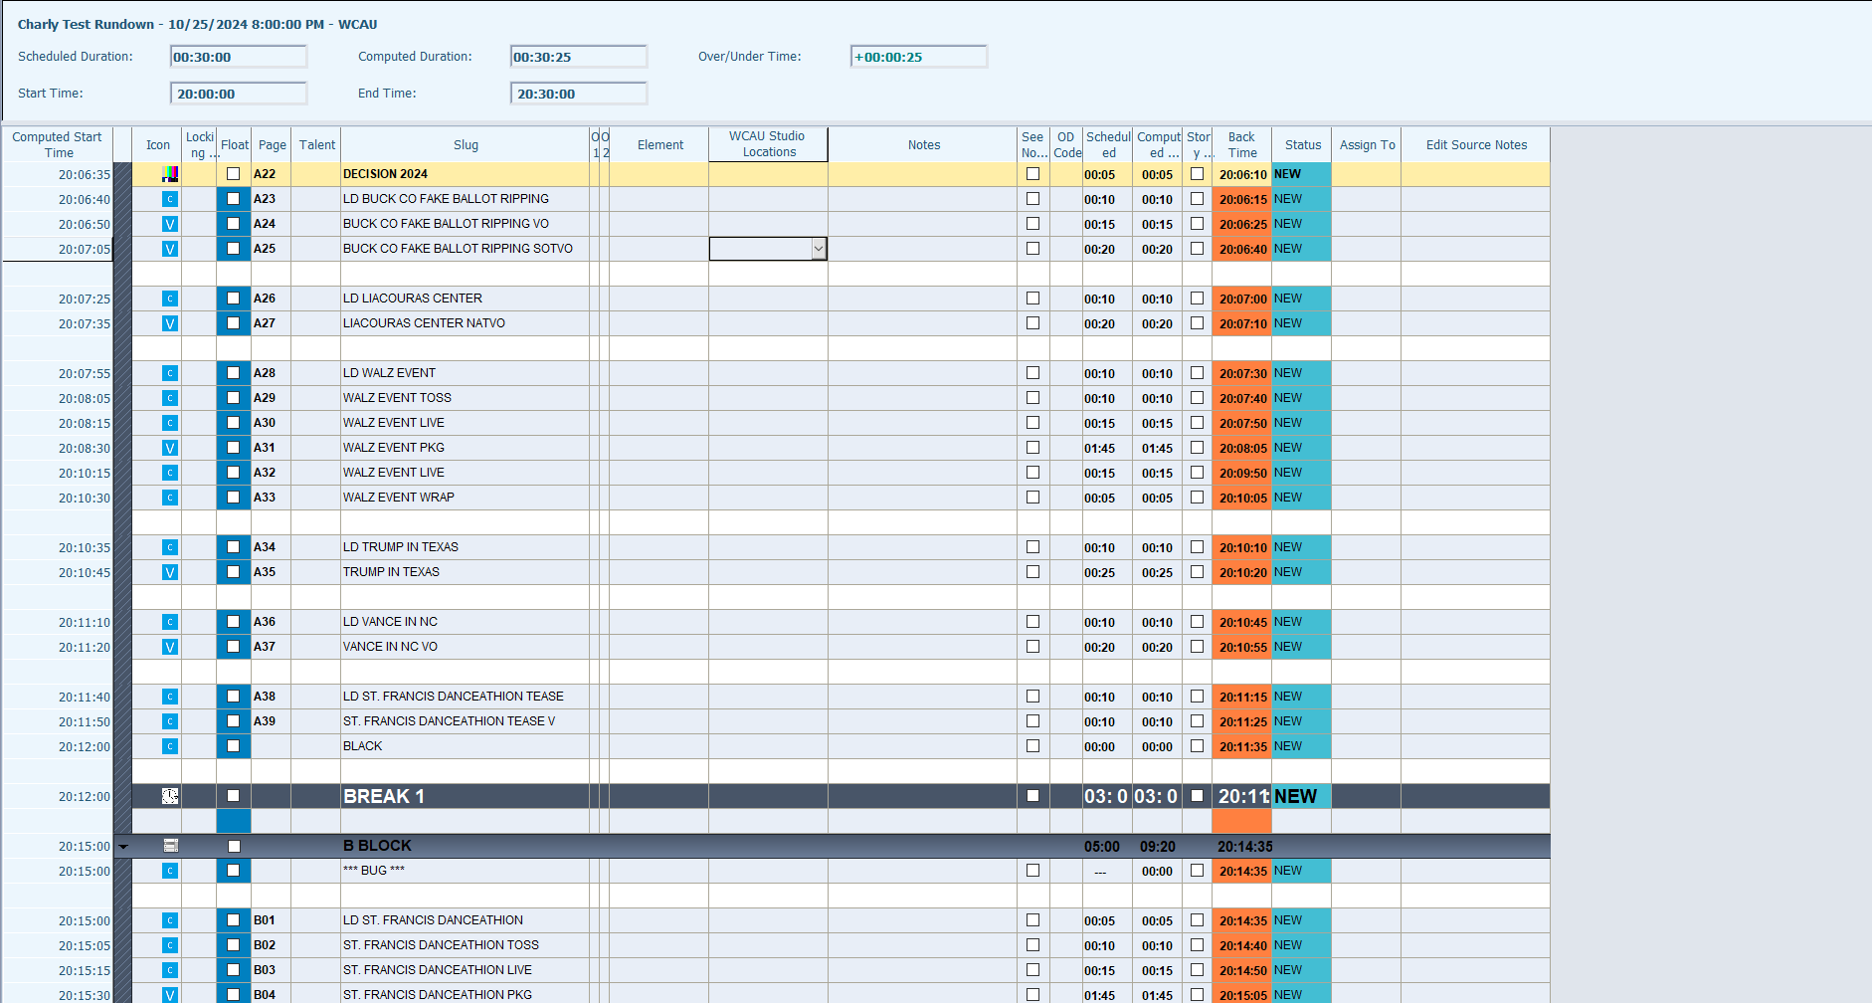

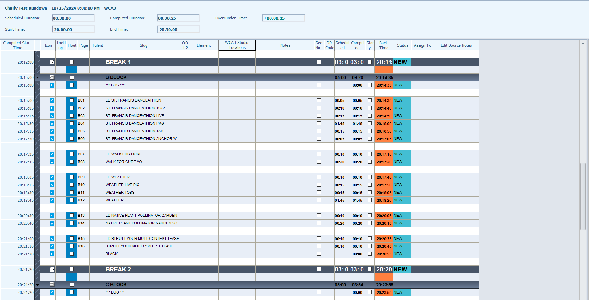

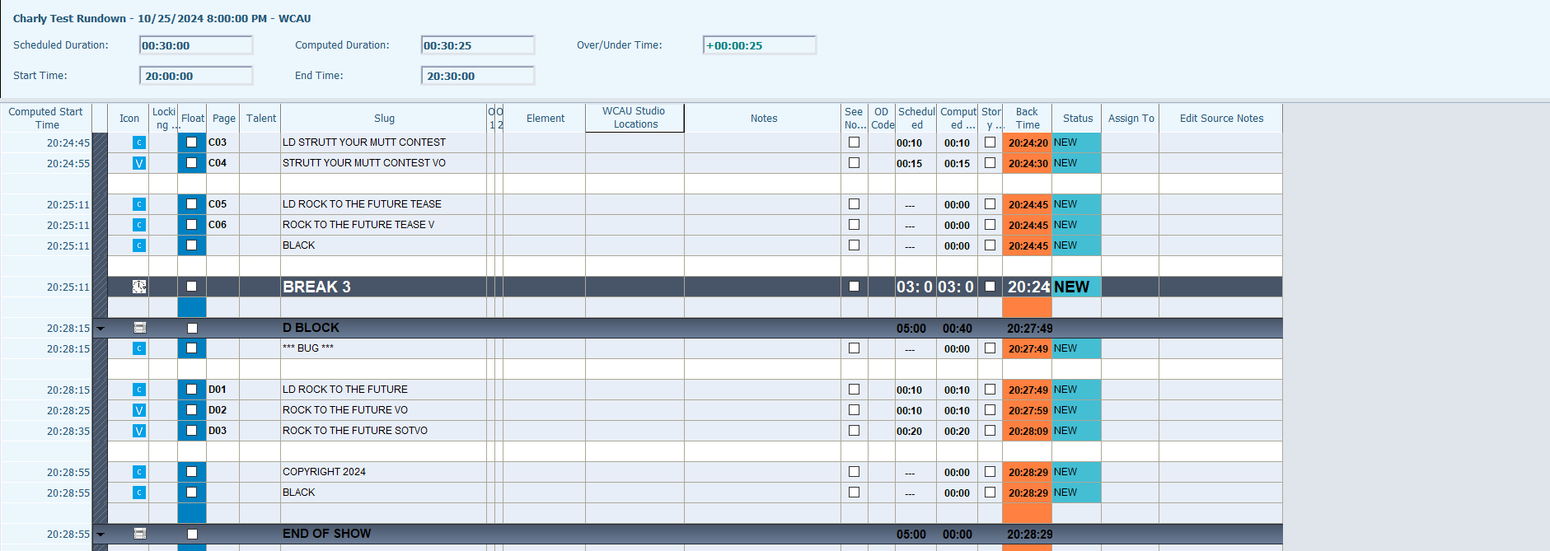

**10/17/2024**

**10/10/2024**

